Job failed because of compile errors. [**SCREENSHOT01]**

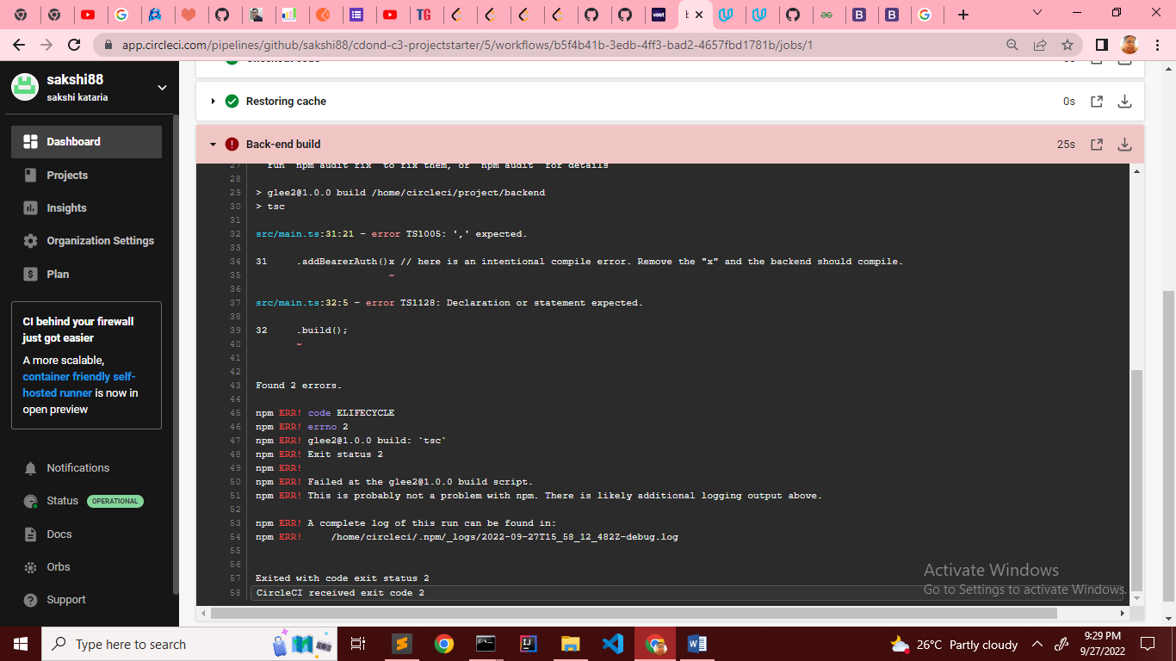

After Fix

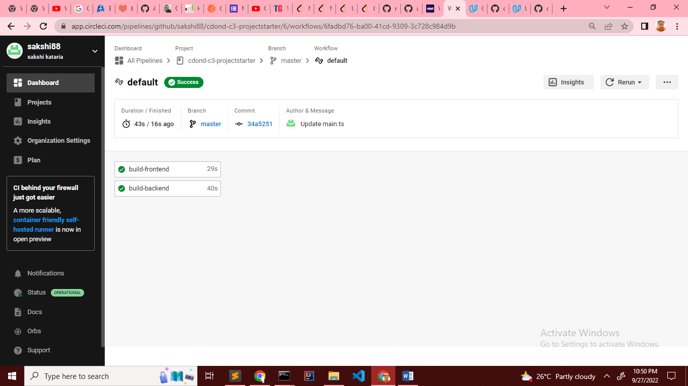

Job failed because of unit tests.[**SCREENSHOT02]**

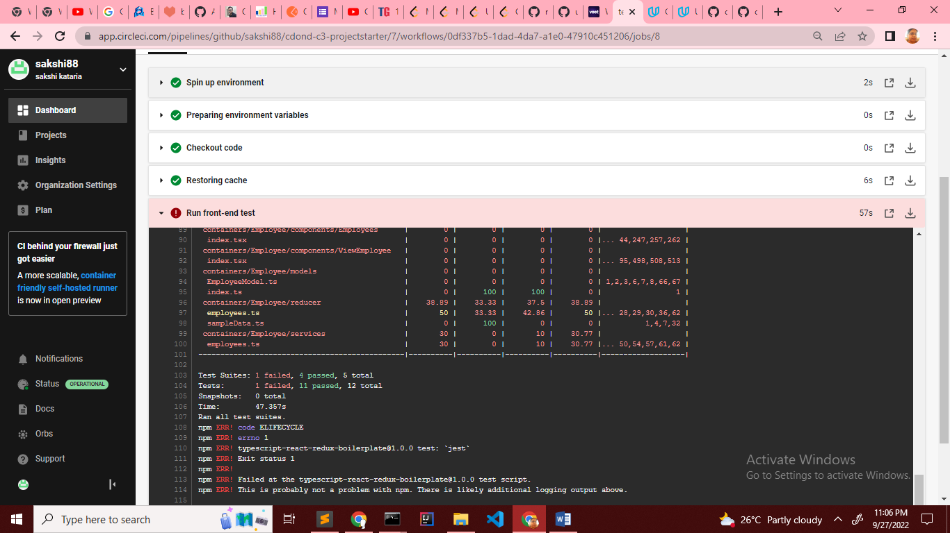

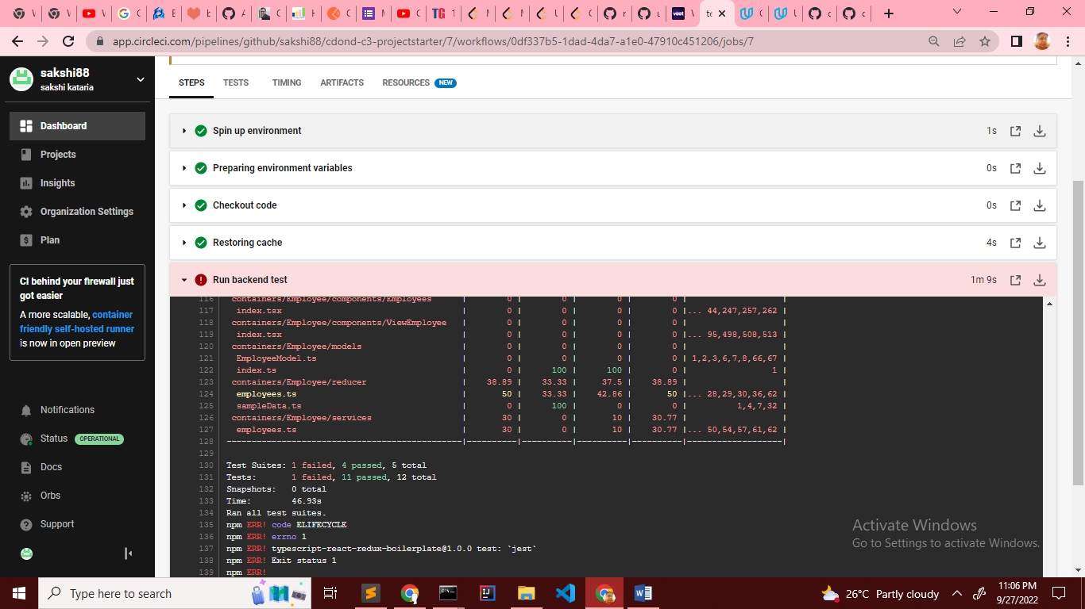

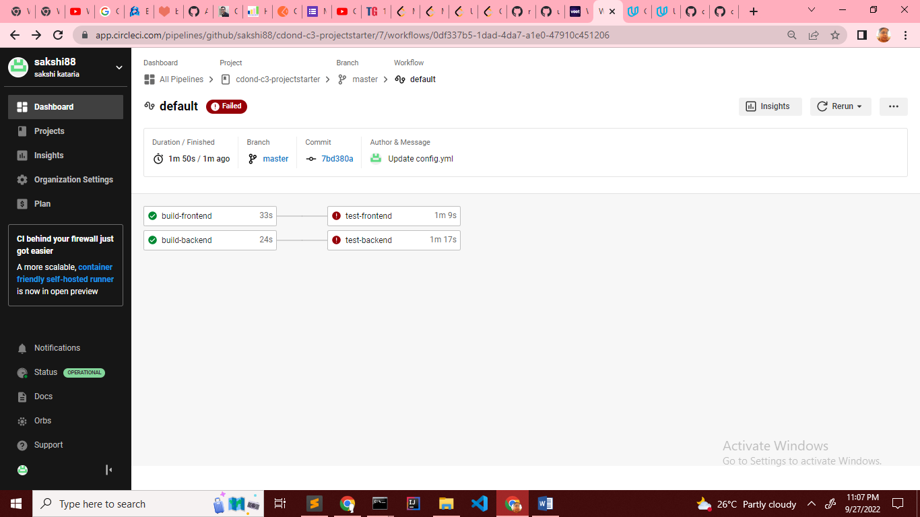

After unit test case fix

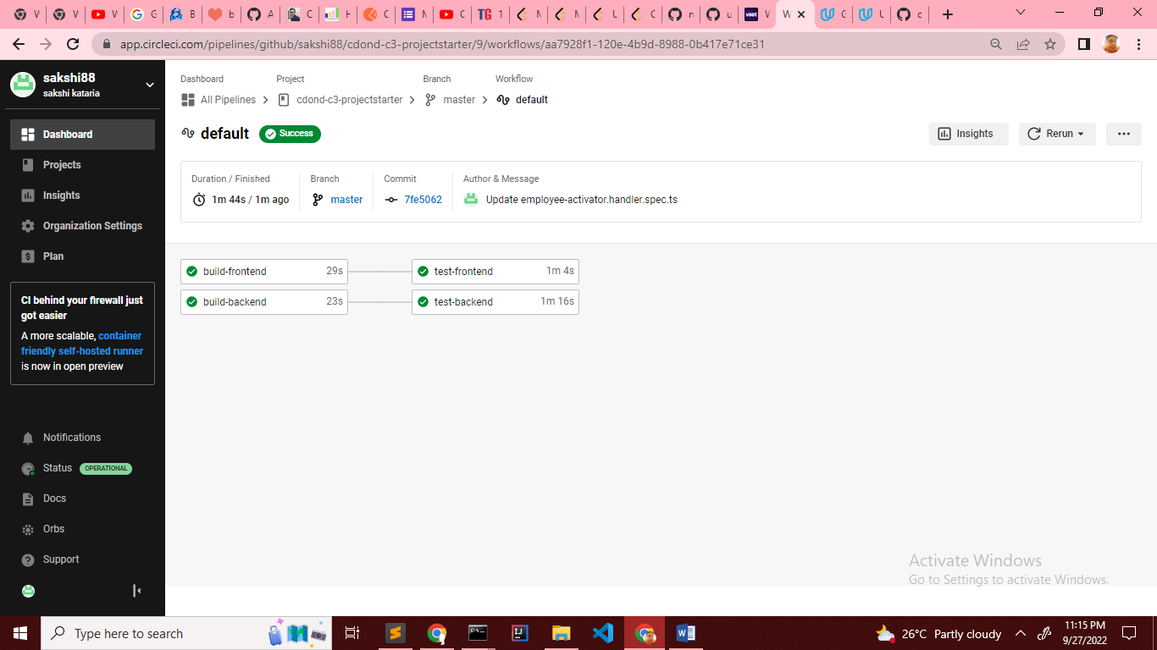

Job that failed because of vulnerable packages.[**SCREENSHOT03]**

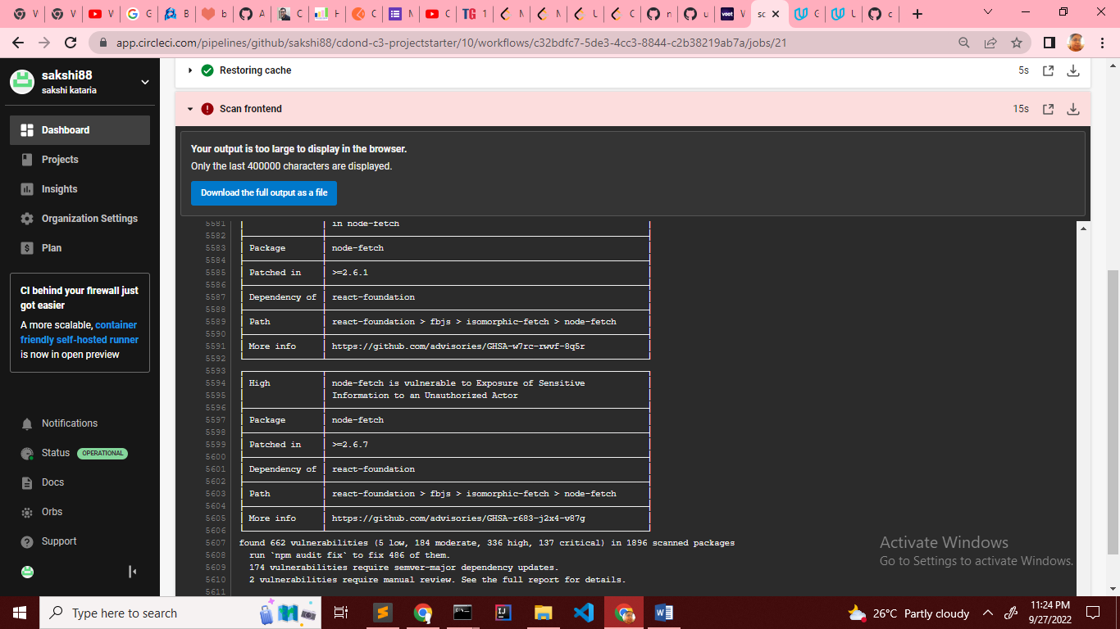

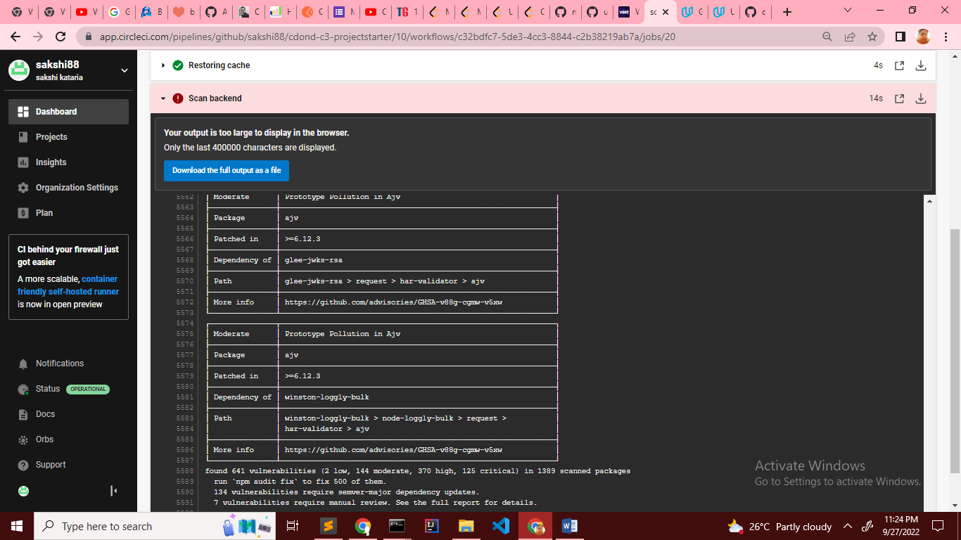

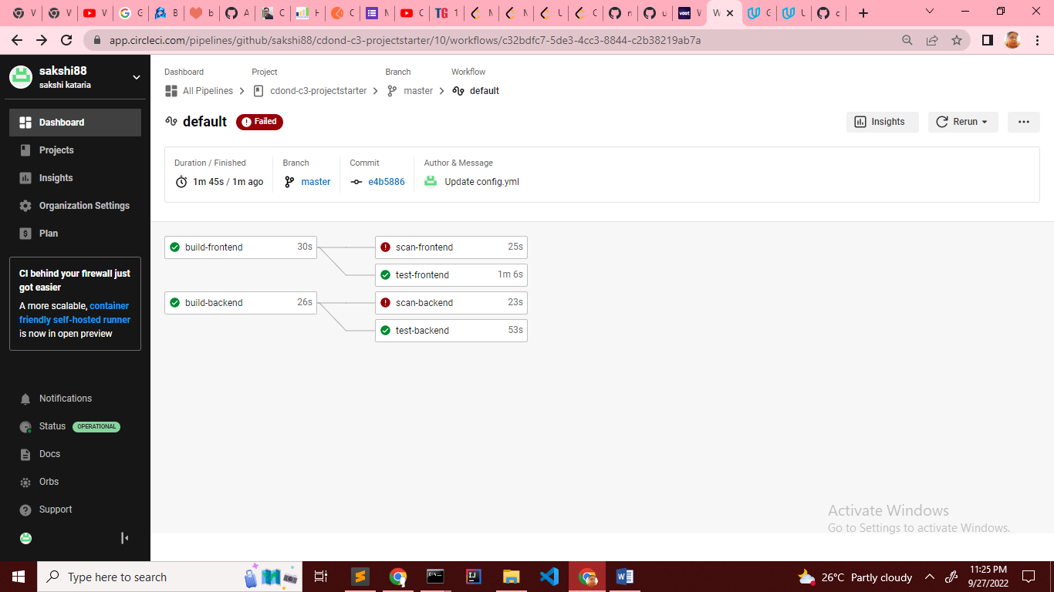

An alert from one of your failed builds.[**SCREENSHOT04]**

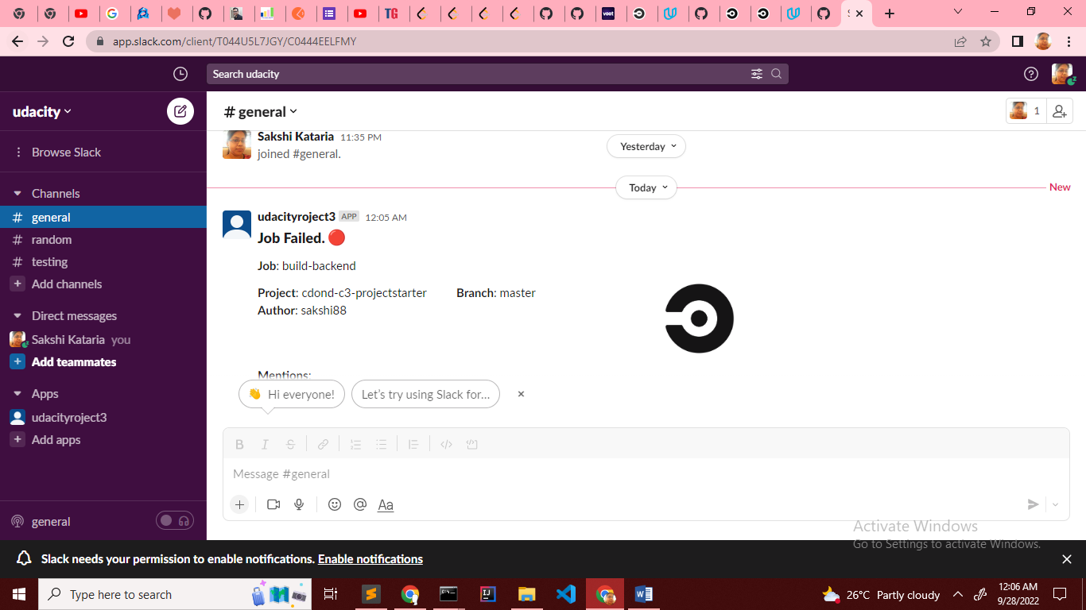

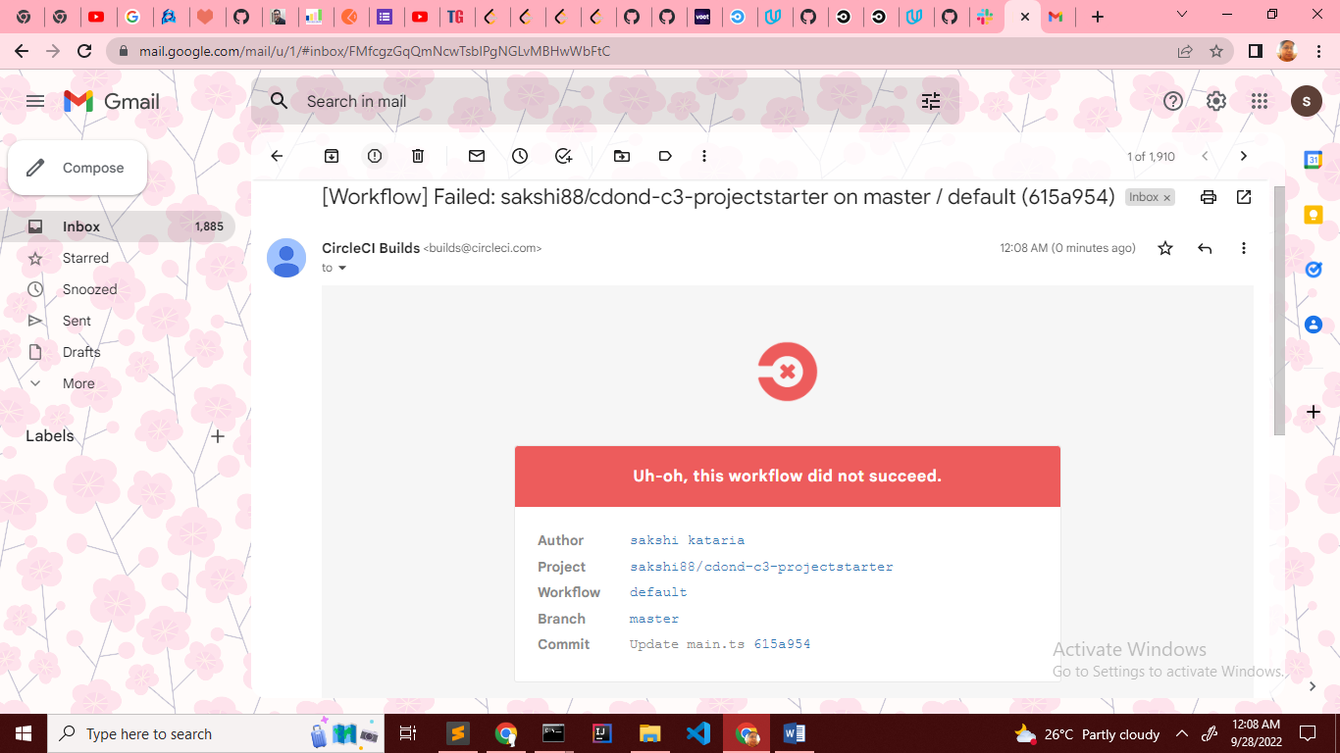

After build-backend and build-frontend passed

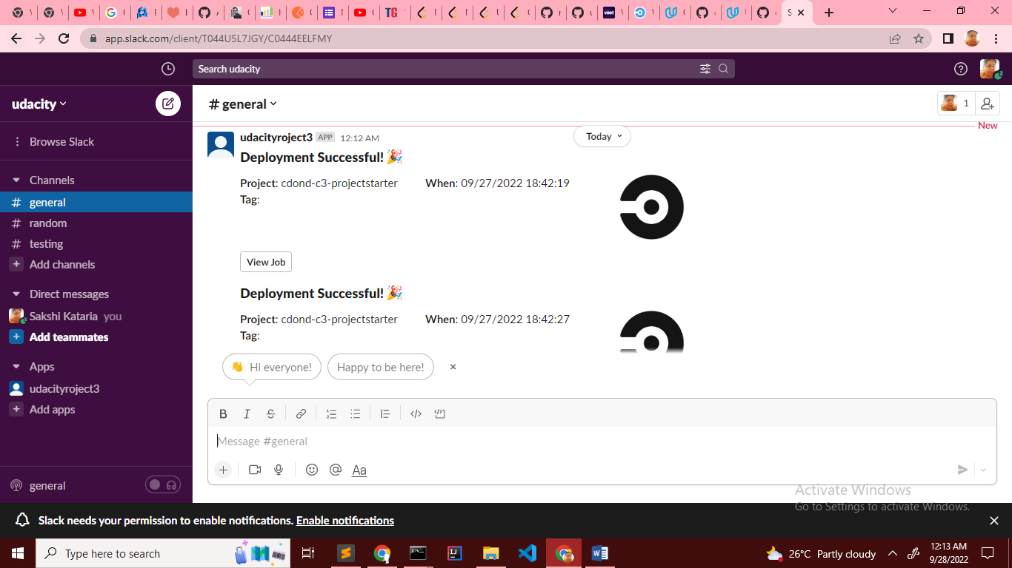

Appropriate job failure for infrastructure creation.[**SCREENSHOT05]**

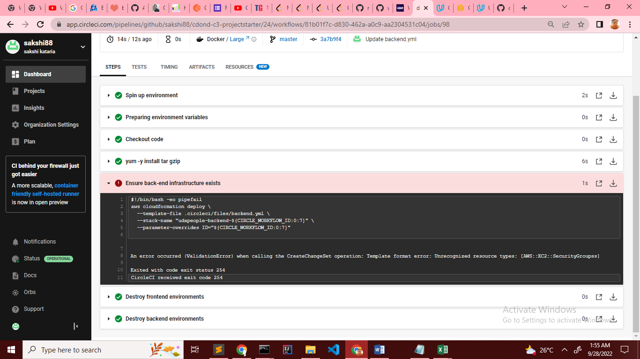

Appropriate job failure for the smoke test job.[**SCREENSHOT06]**

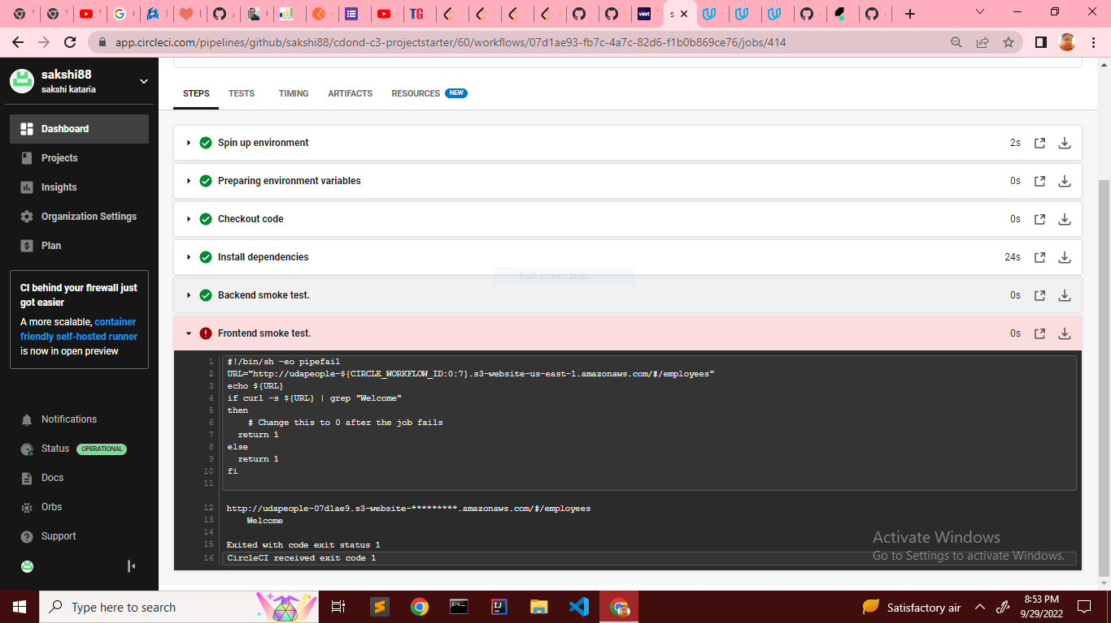

Successful rollback after a failed smoke test.[**SCREENSHOT07]**

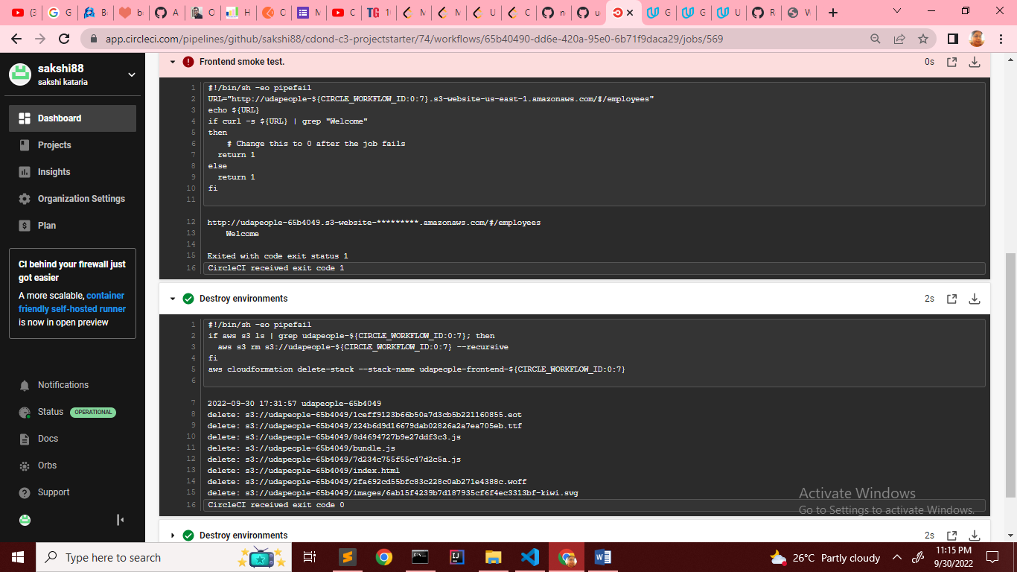

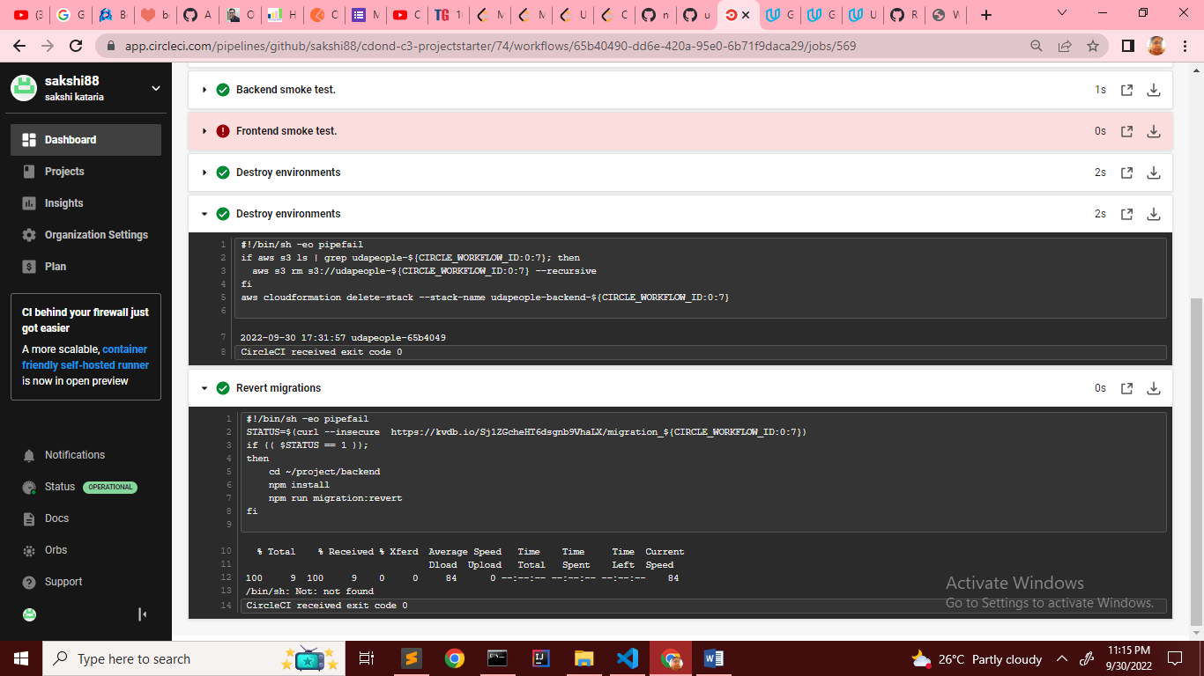

Successful promotion job.[**SCREENSHOT08]**

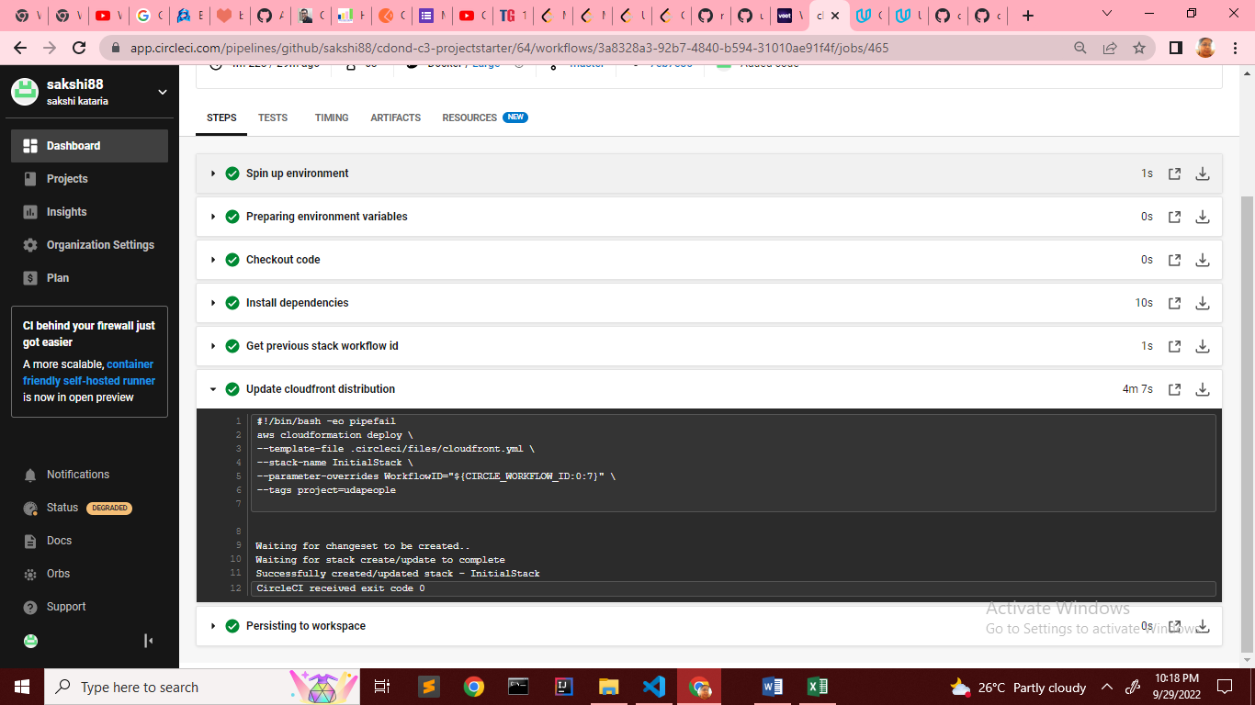

**URL02_SCREENSHOT**

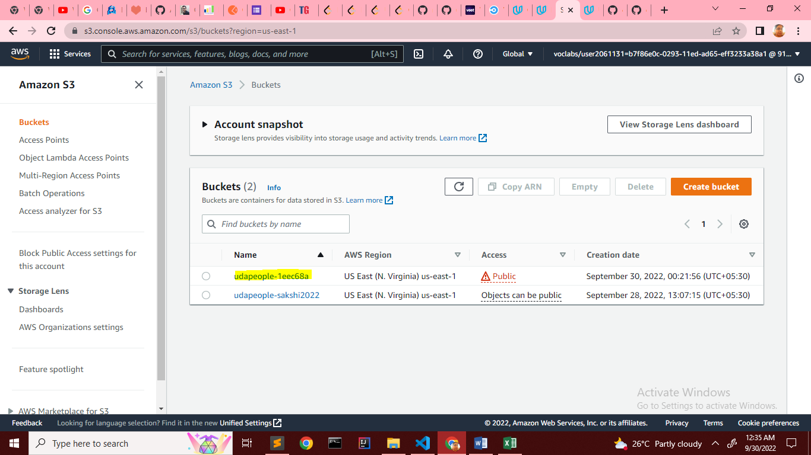

Provide a screenshot showing the evidence of deployed and functioning front-end application in CloudFront (aka, your production front-end)[**URL03_SCREENSHOT]**

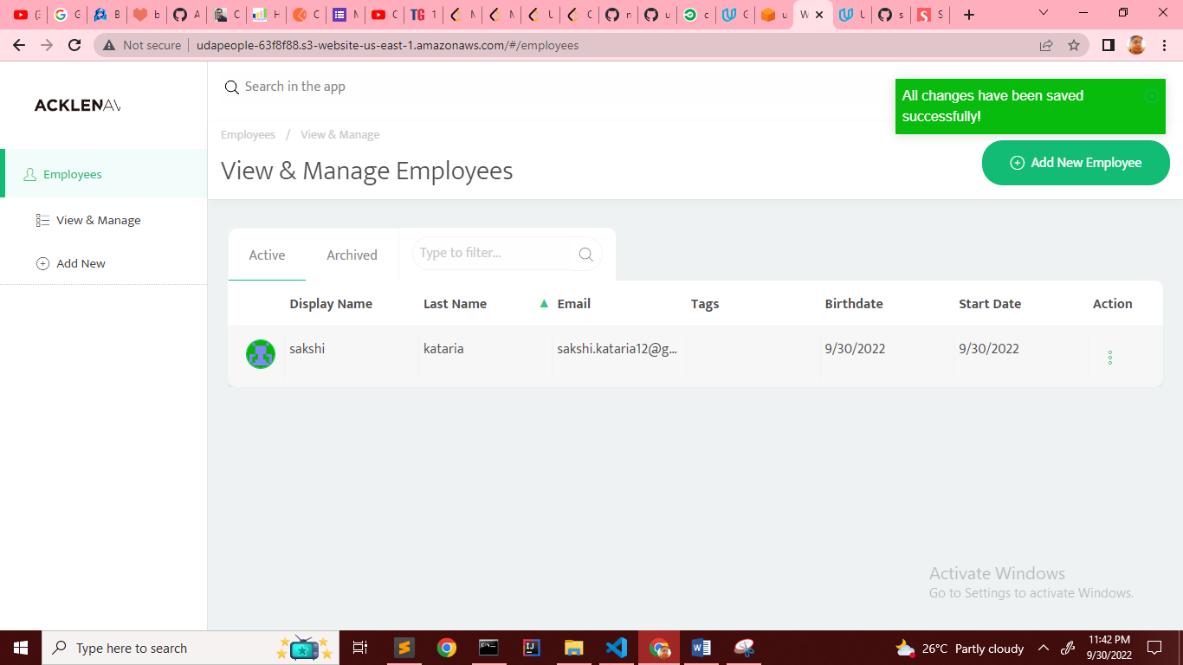

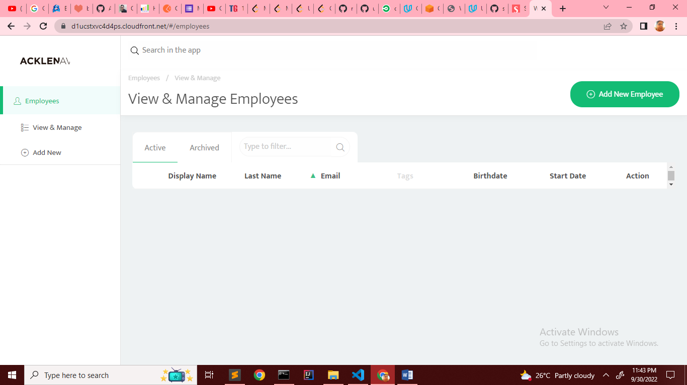

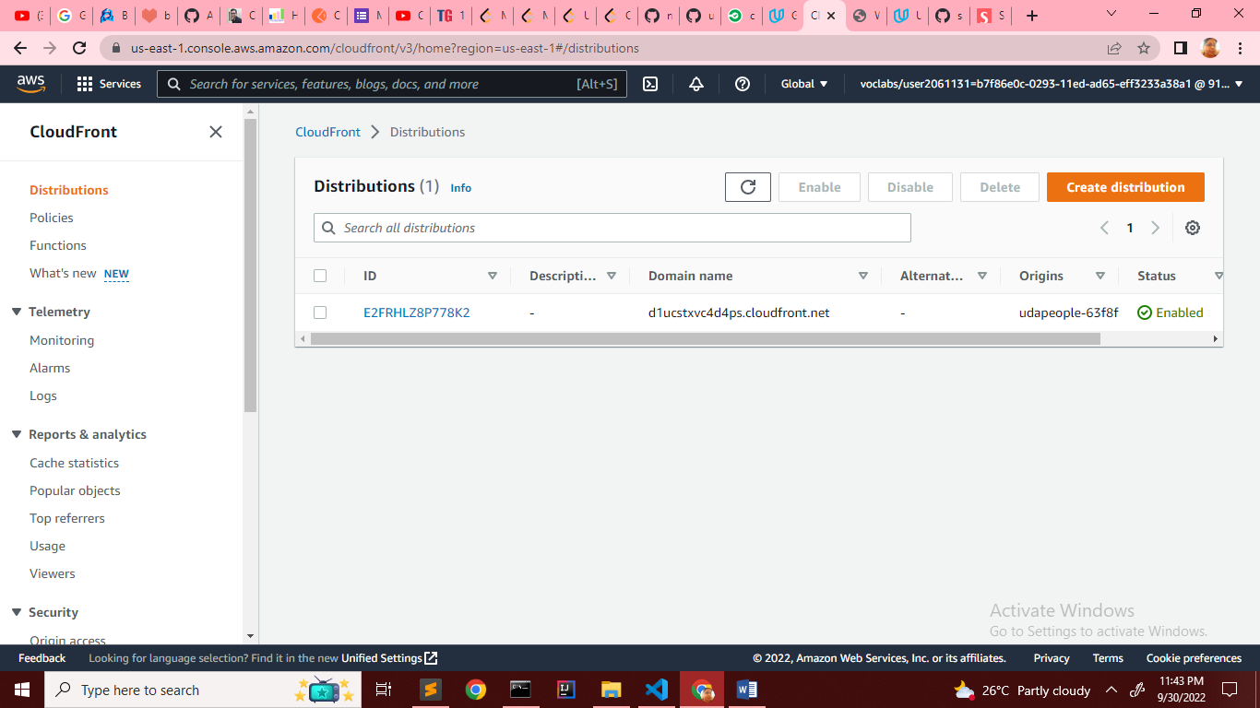

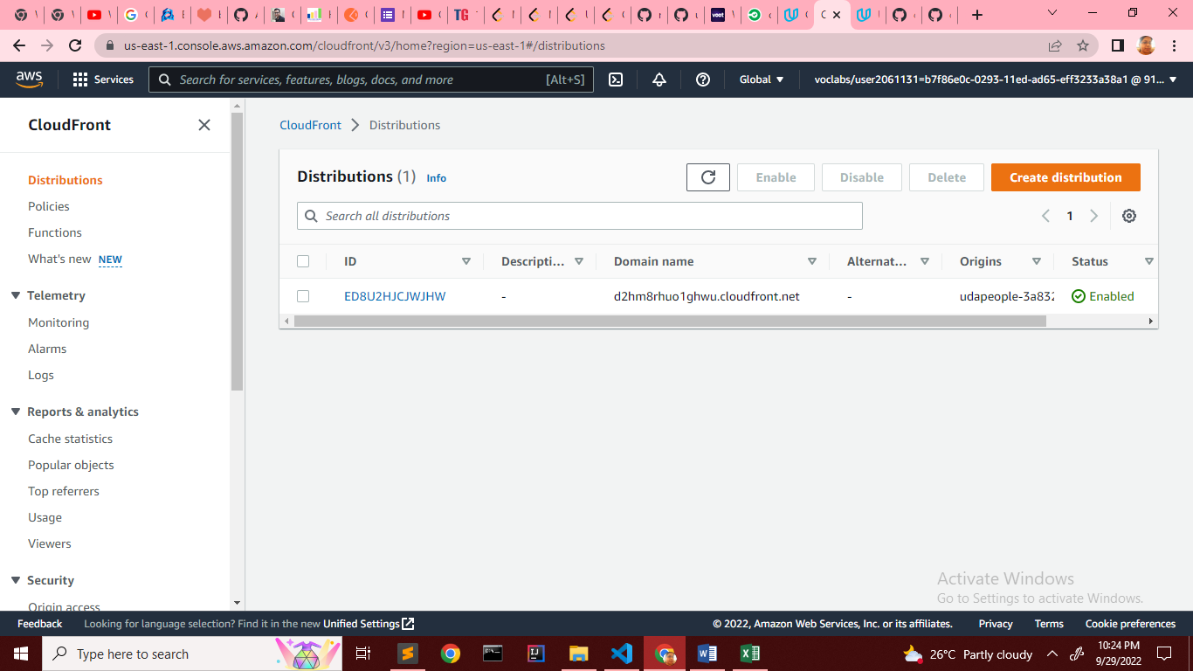

Provide a screenshot showing the evidence of a healthy backend application. The backend endpoint status should show a healthy response.[**URL04_SCREENSHOT]**

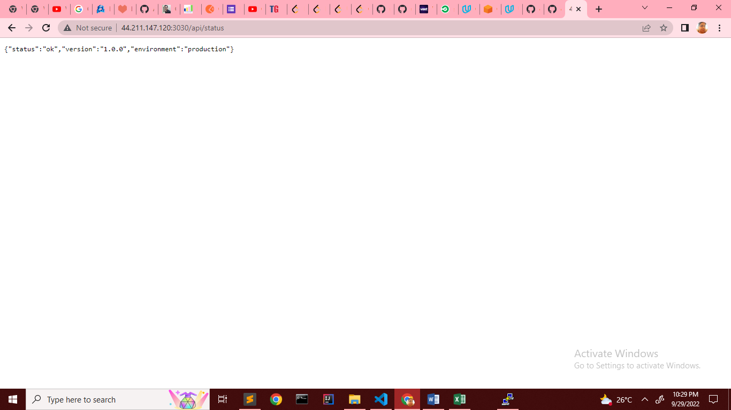

Successful cleanup job. [**SCREENSHOT09]**

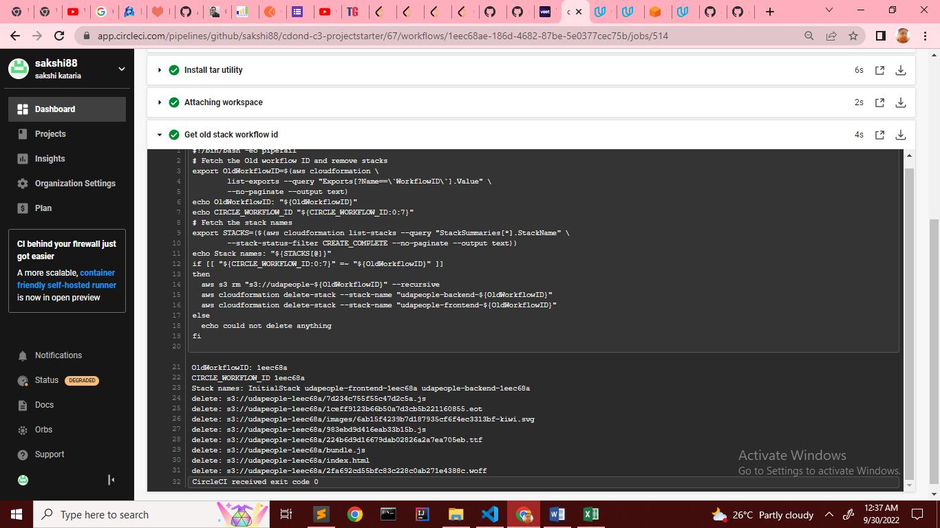

Only deploy on pushed to master branch[**SCREENSHOT10]**

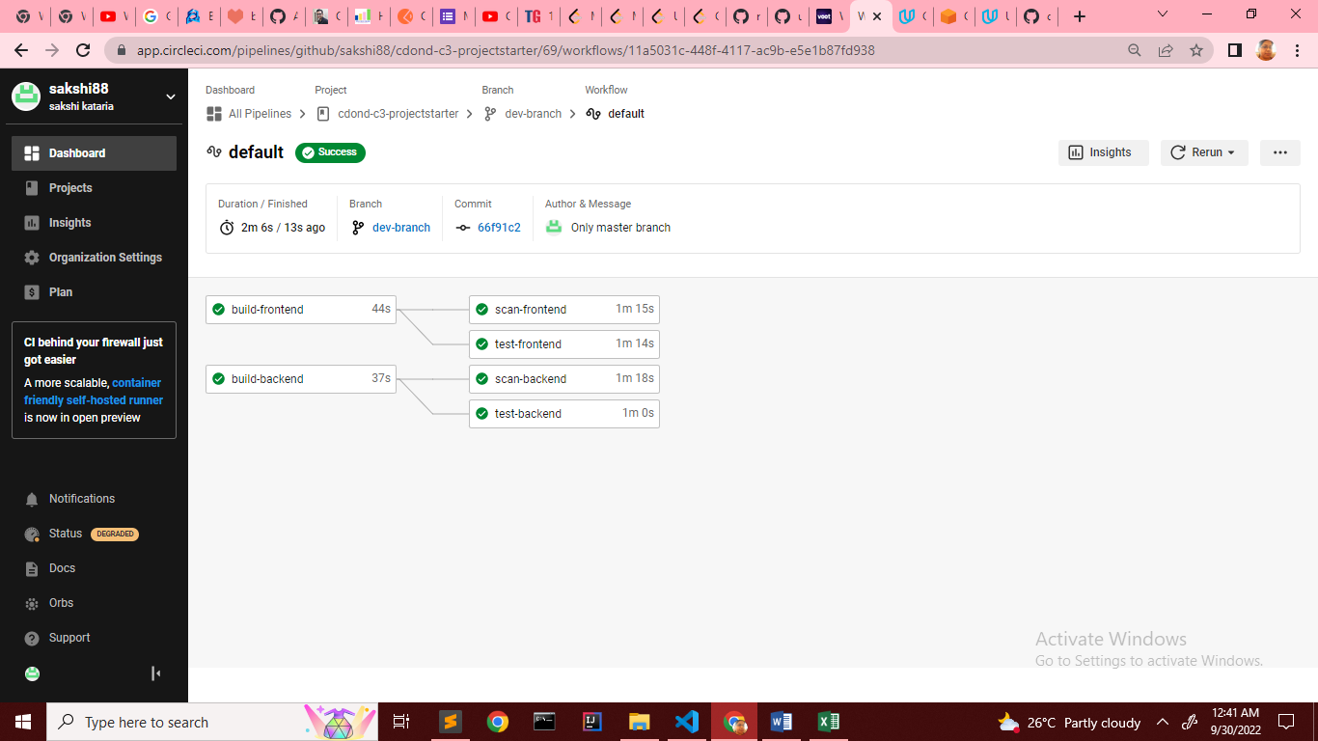

Provide a screenshot of a graph of your EC2 instance including available memory, available disk space, and CPU usage.[**SCREENSHOT11]**

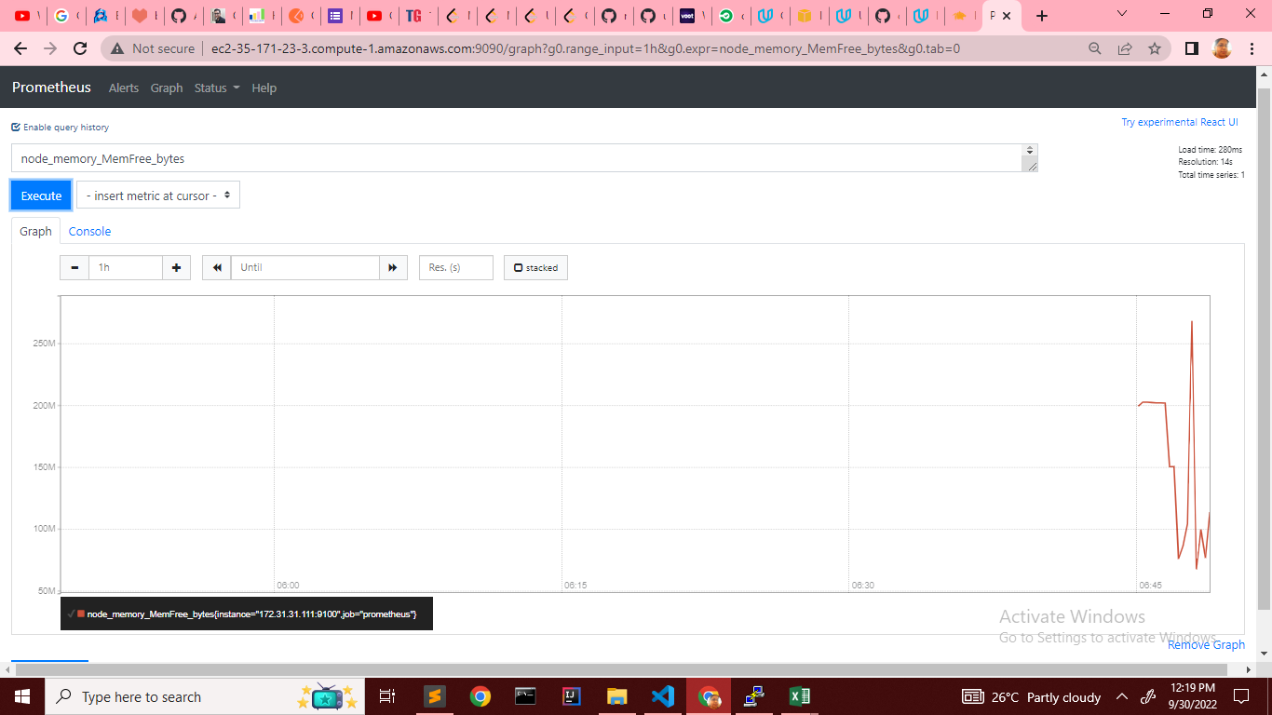

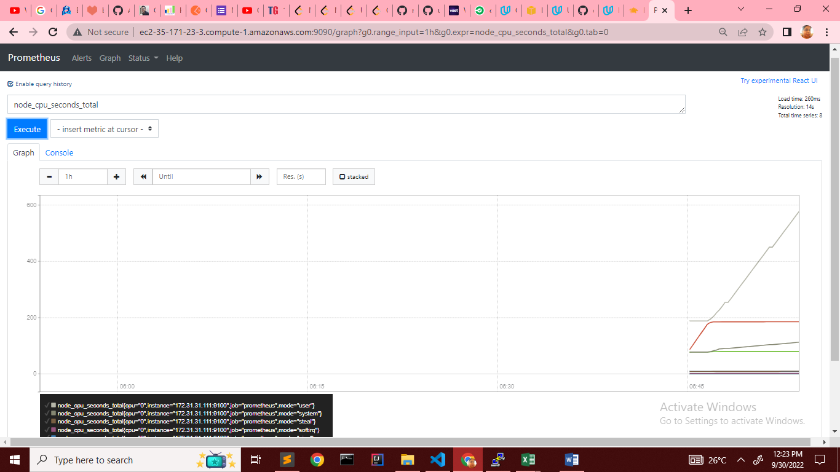

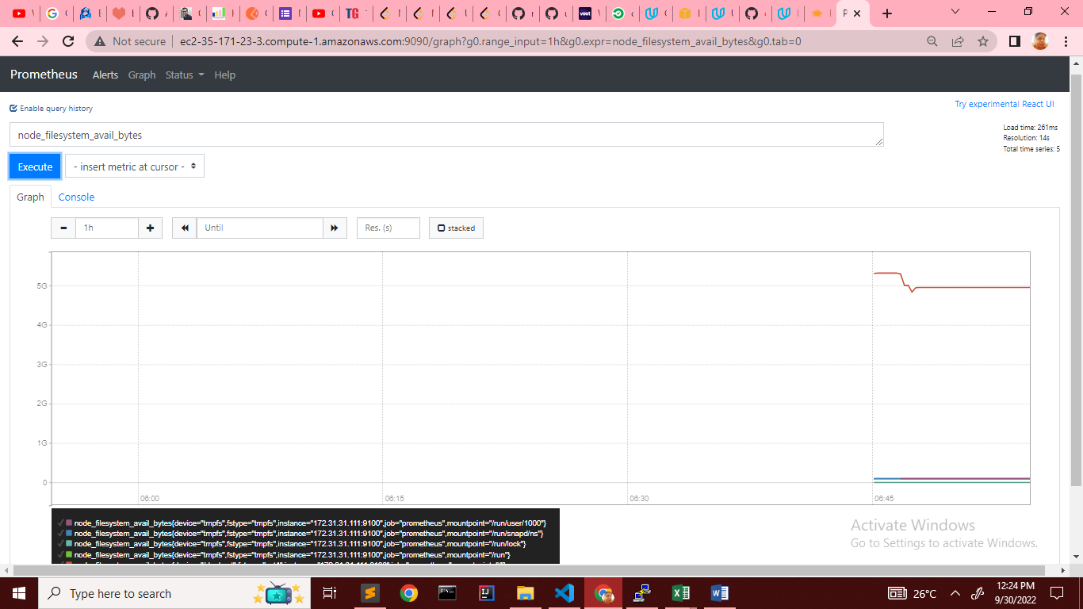

Provide a screenshot of your Prometheus server showing UP state[**URL05_SCREENSHOT]**

1. Udapeople server up and running on port 9100

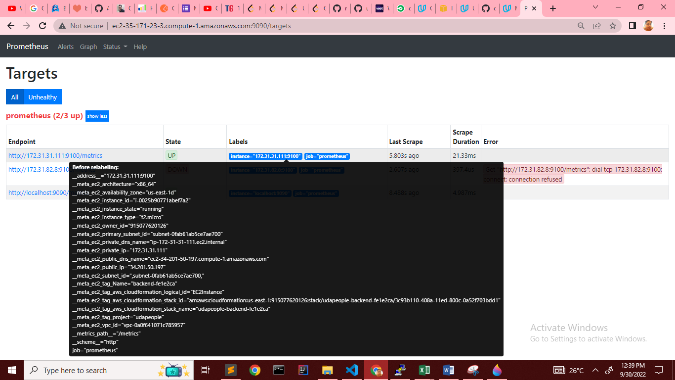

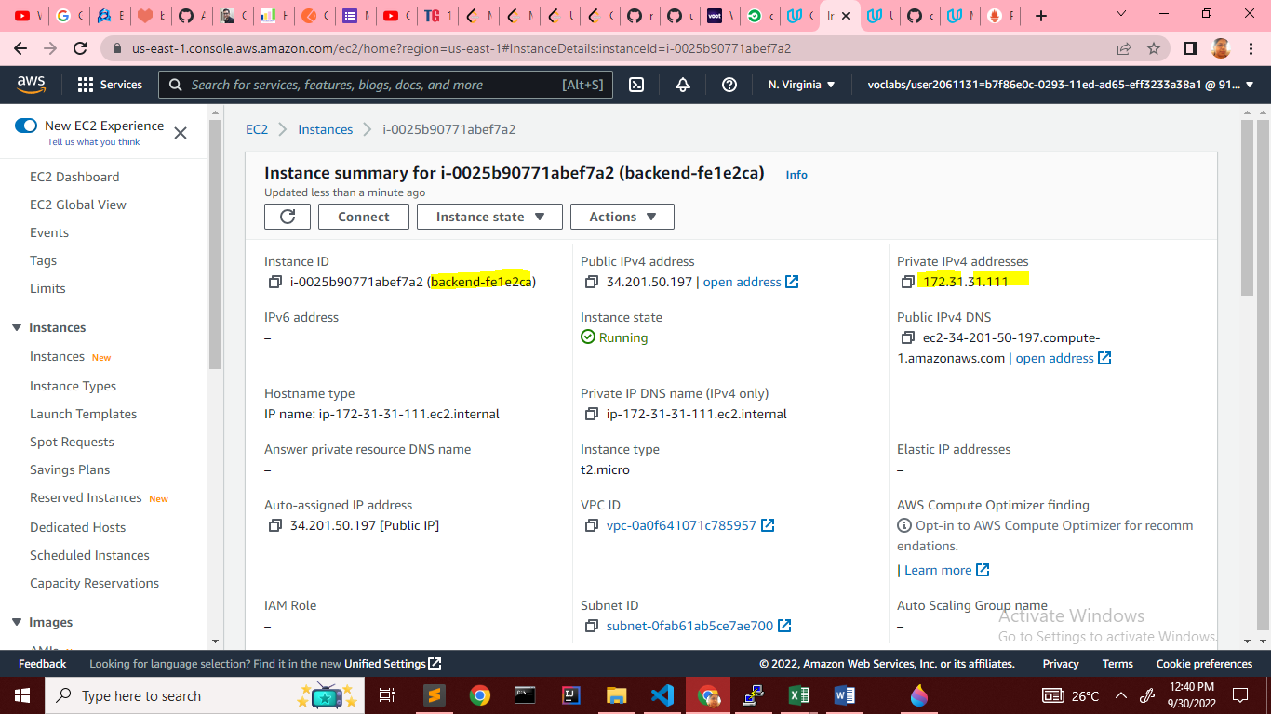

1. Ec2 instance running Prometheus

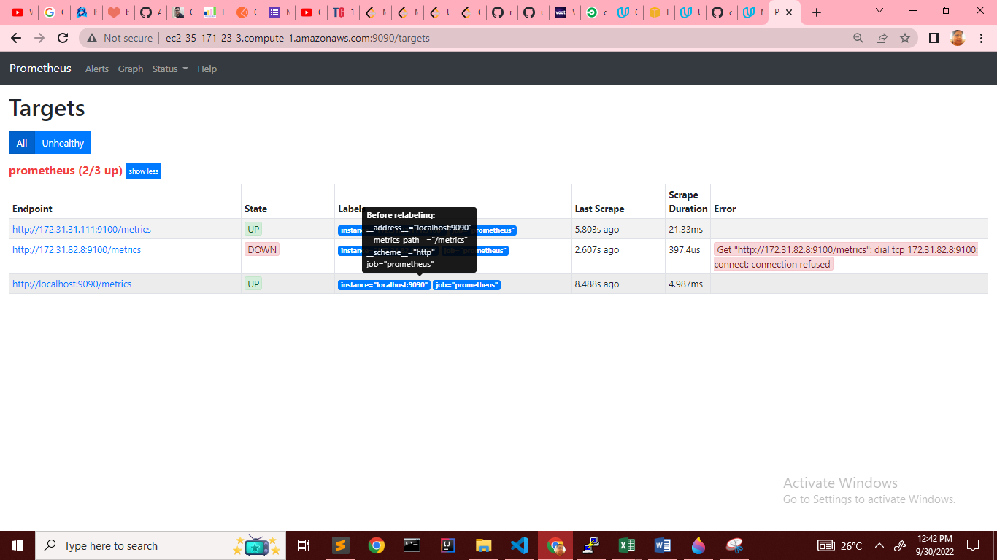

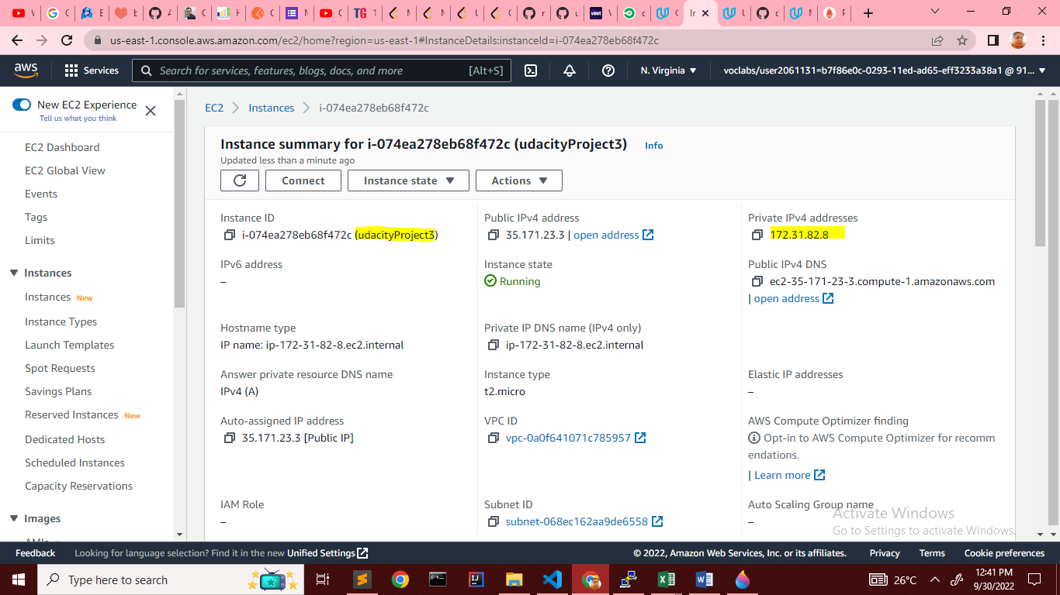

Provide a screenshot of an alert that was sent by Prometheus. [**SCREENSHOT12]**

